

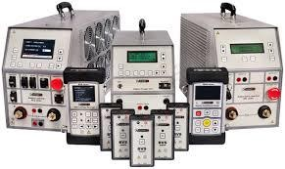
Selected Topics Course
(Communication Lab)

Abstract

This report is a reflection of the knowledge gained in the course, “Selected Topics in Communication Lab.” It covers the various methods used to modify information signals for transmission. The report covers communication features that were unclear in previous theoretical courses. Among the techniques discussed include Amplitude modulation (AM), Double sideband amplitude modulation (DSB-AM), frequency shift keying, amplitude shift keying, phase shift keying, and quadrature amplitude modulation. Apart from explaining the logic used by the techniques, the report also provides experimental demonstration of the processes.

Table of Contents

Abstract 2
Table of contents 3
Communication Systems 4
Frequency Ranges 5
LAB Transmitter Board and Another Measurement Equipment 5
Amplitude Modulation (AM) 7
Generation of DSB-AM 7
Frequency Modulation (FM) 13
Amplitude-shift keying (ASK) 16
Phase shift-keying (PSK) 17
Frequency shift-keying (FSK) 18
Quadrature amplitude modulation (QAM) 20
Conclusion………………………………………………………………………………………..20
References………………………………………………………………………………………...21

Communication Systems

In communication, information is transmitted through electrical wave signals. However, most of these signals are not appropriate for transmission and they often need some modification. This modification is known as modulation and involves altering some features of a carrier signal to ease transmission. This carrier signal foster the transportation of the information signals across a band-pass channel from the information source to the receive. Upon reaching the intended location the signals have to be demodulated to retrieve the original information signal. This process is demonstrated in figure 1 and 2 below where it starts from the information source where the transducer converts the message into electronic signals before modulating it for transmission. The signals are collected by a receiver and being converted to the original message for easier interpretation by the recipient.
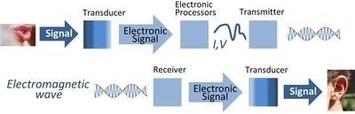
Figure 1

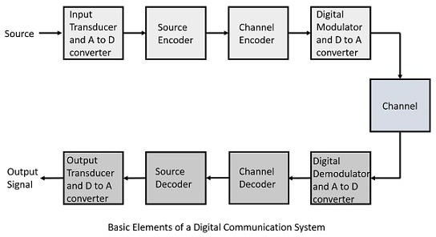
Figure 2
Frequency Ranges

Communication makes use of electromagnetic waves for transmission of signals. These wave signals have diverse attributes such as differing wavelengths and frequencies. However, these attributes can be modified to enable transmission of communication signals. The usable frequency for signal transmission rages from a few kHz to several GHz. Communication makes use of radio waves, which are part of electromagnetic waves with frequencies ranging between 10⁴ and 10¹² Hz, thereby making them viable for long-distance communication. Figure 3 shows the frequencies of radio waves used in radio communication.

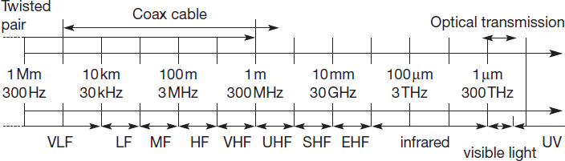
LAB Transmitter Board and Another Measurement Equipment
Figure 3

In the laboratory, there are a variety of components that facilitate the understanding of the available communication technologies. Of the main components is the experiment board which has a number of functional units. This component is shown in figure 4.

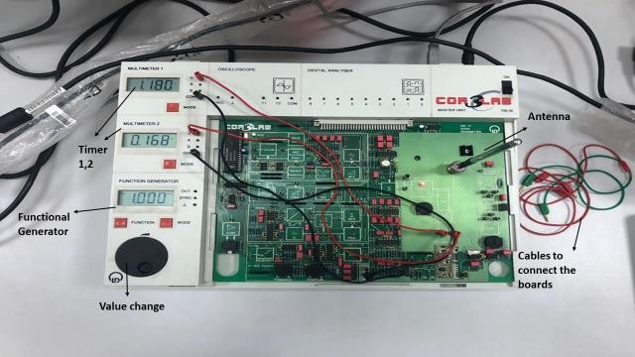
Figure 4

In doing the first experiment in the course, a simple transmission way was set up. A mobile phone was connected to a board through the Bluetooth technology. And the signals were modulated through the experiment board. The signals were then transmitted through the antenna so that they were received by the second experiment board with another receiver. The various equipment used in the experiment for transmission technology include the following:
- Oscilloscope
- Frequency counter
- Spectrum analyzer
- Network analyzer
- Reflectometer
- SWR meter.
Amplitude Modulation (AM)
Amplitude modulation is a technique that is common in modifying radio waves for transmission. It involves varying the signal strength in proportion to the information signal to make it appropriate for transmission. It is common in broadcasting and two-way radio communication. It is one of the earliest techniques of signal modulation developed in the first quarter of the 20th century. The system only requires the carrier amplitude to be modified with the use of a simple diode-based circuit as the detector.

Generation of DSB-AM

The experimental setup for investigating the generation of double sideband amplitude modulation is shown in figure 5 below. It involves the multiplication of two wave signals in the domain of frequency and time. The components required include a carrier signal with a frequency of 10kHz, a variable sine, and wave from the function generator.
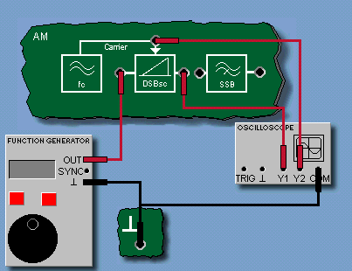
Figure 5
The setup is made by connecting the oscilloscope and function generator as shown in figure 5 and the function generator is set at DC, 1V. The oscilloscope is opened and the amplitudes of Y1 and Y2 measured. The modulation coefficient kM is then calculated and the results entered in the relevant field. The left input of the modulator is biased with a DC of 1V. The amplitudes of Y1 and Y2 are generated as shown in figure 6.
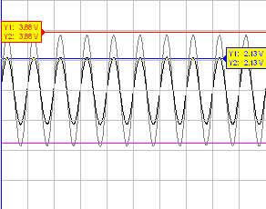
Figure 6

The function generator is set to a sine frequency of 200 Hz and 10 Vpp followed by the opening and adjustment of the settings to show the curve as shown in figure 7 (X/div = 0.5 ms). The frequency is then elevated to 4 kHz and the changes to the wave curve in the oscilloscope. These changes are demonstrated in figure 8 and 9.
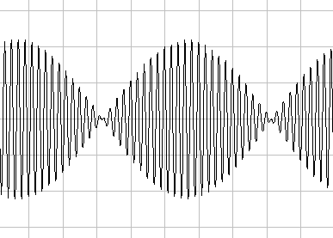
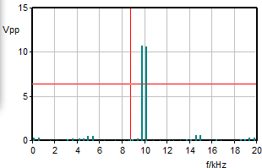
Figure 7
Figure 7

Figure 8
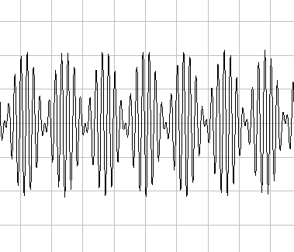
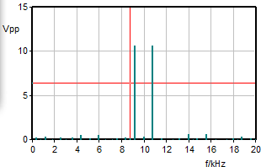

Frequency (780 Hz)

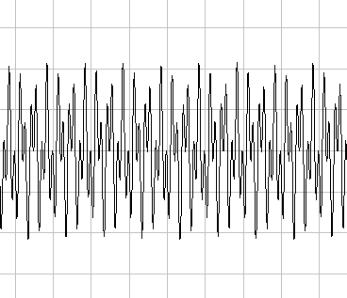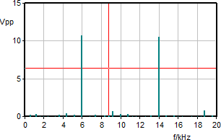
Figure 9
The frequency of the function generator is then adjusted to 1 kHz and the signal shape changed from triangular to square wave as shown in figure 10.
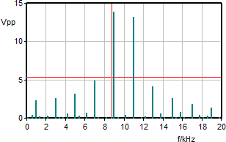
Figure 10
The connection to function generator is detached and a connecting lead used instead to link the input of the modulator to the carrier socket as shown in figure 11. The first signals in oscilloscope are then observed and they appear as shown in figure 12
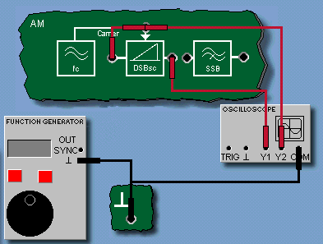
Figure 11

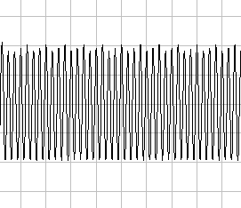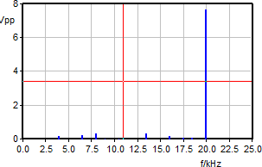
Figure 12

The circuit is further set is shown in figure 13 which demonstrate the AM transmitted carrier. The function generator is set to sine of 1kHz, 10 Vpp, and DC of 0V and the oscilloscope adjusted so that the curve characteristic is shown (X/div = 0.5 ms). The signals in the oscilloscope are as shown in figure 14.

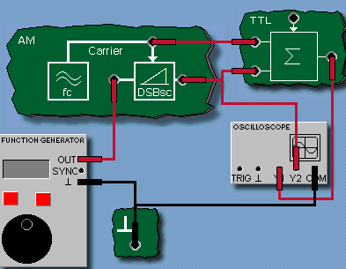
Figure 13

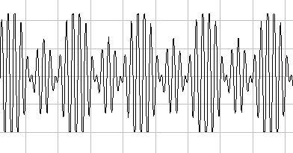
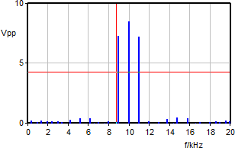
Figure 14

When the frequency settings are randomly adjusted between 500 Hz and 2000 Hz with an amplitude of between 0 Vpp and 10 Vpp, the signal diagrams are as shown in the following figures.
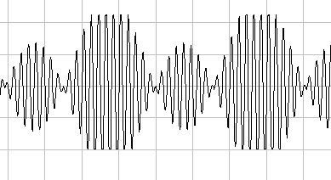
Figure 15: 500 Hz, 10 Vpp

F=500Hz, V=10 Vpp

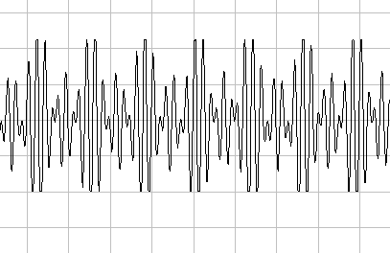
Figure 16: F = 1500 Hz, V = 10 Vpp

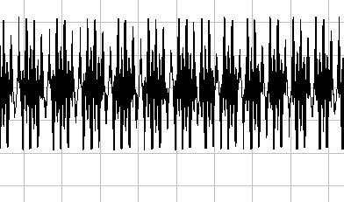
Figure 17: F= 2000 Hz, V = 10 Vpp
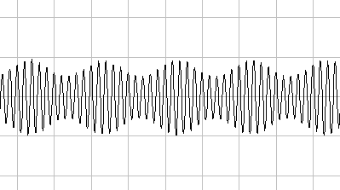
Figure 18: F = 1000 Hz, V = 2 Vpp
When the connection between the upper input and the carrier is removed as shown in figure 19, the carrier disappears from the wave spectrum. When the DC component of the function generator is slowly increased to about 2V, the carrier reemerges in the output signal as shown in figure 20.
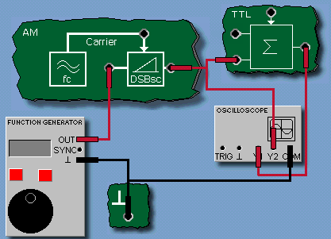
Figure 19

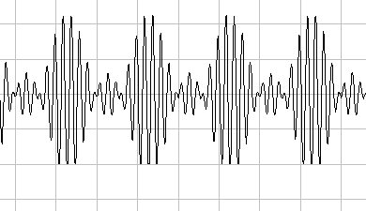
Figure 20

Frequency Modulation (FM)
Frequency modulation involves modifying the electronic signals of information by altering the instantaneous frequency of the original message signal. It provides high quality audio thereby making it more viable for short, medium, and long wave bands. This technique together with phase modulation (PM) for the category of angular modulation methods. FM modulators are often developed as voltage-controlled oscillators (VCOs).
The experimental setup to demonstrate frequency modulation shows the static features of a VCO. By using the amplitude controller, the amplitude of a VCO output can be adjusted accordingly. The oscilloscope and the function generator are set on the experiment board as shown in figure 21 and the function generator set to 0 V.
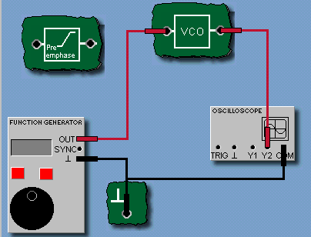
Figure 21
The frequency counter is opened and the trigger set to +Y2 before turning the amplitude potentiometer to maximum. The frequency potentiometer is adjusted so that the output frequency is about 10 kHz. The DC voltage is set to -10 V. The plotter of characteristics is opened and the (U, f) value pair entered. The voltage at the VCO input is the increase in units of 2.5 V upto 10 V. The measured value pairs are entered into the table as shown in figure 22 and the input voltage set to 0 V. The modulation coefficient k is determined when Uin = 0 V based on the slope of the plot (k = - 282.8
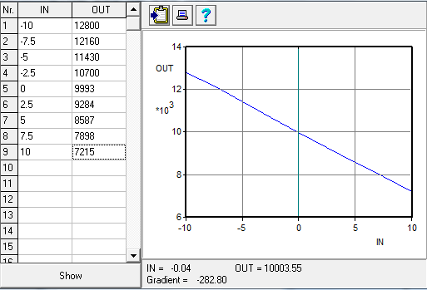
Figure 22

There is another experimental setup related to frequency modulation signal. The oscilloscope and the function generator are connected to the experiment board as seen in figure 23 with the DC of the function generator being 0 V. The FFT module is also opened and set at Y1, fmax = 20 kHz before starting the measurement recorded in figure 24.
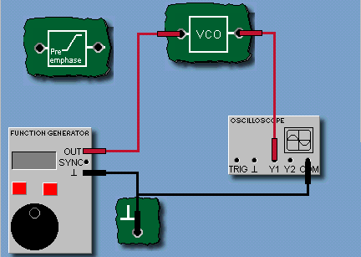
Figure 23

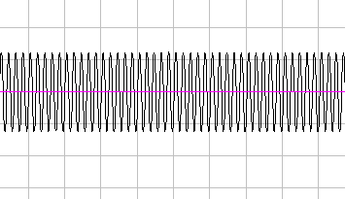
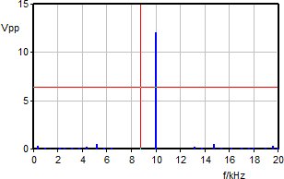
Figure 24
Amplitude-shift keying (ASK)
ASK is a variation of amplitude modulation that uses discrete units to represent the changes in the carrier wave. The ASK system makes use of the binary symbol 1 to signify the transmission of a carrier wave with a fixed amplitude and fixed frequency for specified duration of T seconds. If the signal value is 1 the carrier wave will be in transmission; if otherwise, a signal value of 0 will be in transmission. The transmission in ASK is demonstrated in figure 25.
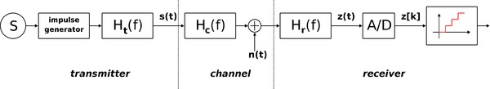
The ASK system has three blocks, including the transmitter, transmission channel, and the receiver. The various notions used in this finding the wave function in this method include the following:
Figure 25: Demonstration of ASK
- Ht (f) is the carrier signal
- Hc (f) is the impulse response of the channel
- n(t) is the noise introduced by the channel
- Hr (f) is the filter at the receiver
- L is the number of levels that are used for transmission
- Ts is the time between the generation of two symbols
Phase Shift Keying (PSK)
PSK is digital modulation technique that transmits information by modulating the phase of a constant frequency in reference to the carrier wave. This modulation is achieved by changing the sine and cosine at a specified time. The technology is common in Bluetooth communication, RFID, and wireless LANs. PSK is highly immune to interference.
In an experimental setup, PSK signal is generated using an AM modulator connected to a pure AC signal. Its wave spectrum aligns to that used in DSB-AM signal in absence of a carrier. The oscilloscope and function generator are connected on the experiment board as shown on figure 26. The function generator is set to square wave, 1 kHz, 4 Vpp, 0 VDC, and 50 % pulse duty cycle. In the oscilloscope, the settings include Curve dual, x/div = 100 μs, Y1/div = Y2/div = 5 V, trigger off. The FFT module is set at Y2, fmax = 20 kHz and the wave signals appear as shown in figure 27.
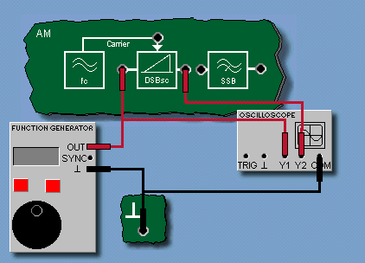
Figure 26
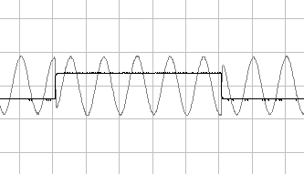
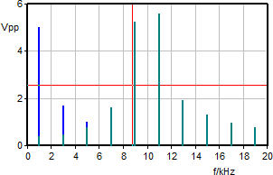

Figure 27

Frequency shift-keying (FSK)
In this technique, the digital information is conveyed by making discrete modification of the carrier signal frequency. Information is transmitted at discreet frequencies of f1 and f2. Absence of transmission signal is linked to faulty transmission line. FSK is specialized method of frequency modulation transmission, thereby explaining its expanded and complex spectrum. It is the recommended form of data transmission through telephone systems using modems. In the perspective of modems, there are distinctions in the operating modes, which include simplex, duplex, half-duplex. Binary FSK is the simplest variant of FSK and uses discrete frequency pairs to transmit information i.e. 0s and 1s. An example of binary FSK is shown in figure 28.
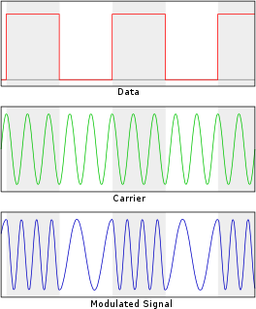
Figure 28: An example of binary FSK

In an experimental setup of FSK, the oscilloscope and the function generator are connected as shown in figure 29 and the function generator set at DC = 0 V. The frequency counter is opened and its operating panel set to Y2. The amplitude potentiometer is turn right to the maximum limit. The frequency potentiometer is set to give an output of 10 kHz. The function generator is the set at square wave, 1 kHz, 20 Vpp, and DC = 0 V. the oscilloscope is set at x/div = 200 μs, Y1/div = Y2/div = 5 V, Curve Dual, and trigger off. The FFT module is set at Y2, f max = 20 kHz and the measurements made as seen in figure 30.
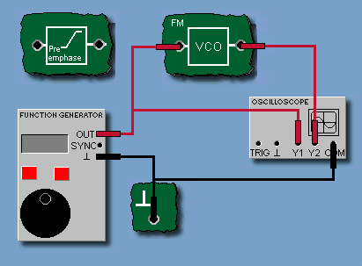
Figure 29

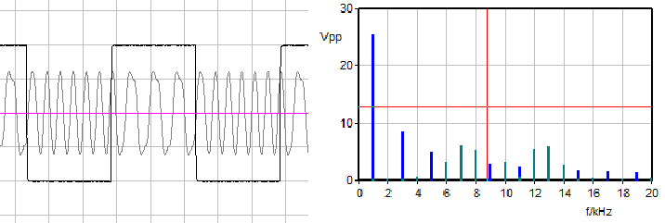

Figure 30
Quadrature Amplitude Modulation (QAM)
QAM is a modulation technique that uses both phase components and amplitude to enable the elevation of spectrum usage efficiency. While it has been utilized for analog transmission such as AM stereo, it mainly for data applications. Through its effectiveness it has been used in communication systems that require high speed data transmission. QAM uses a signal with two carriers that are shifted 90 degrees in phase, i.e. sine and cosine. As a result of the 90-degree orientation, they are in quadrature hence the name. The two wave signals are denoted I and Q notations with the resultant wave signal from their combination showing both their amplitudes and phase attributes; they are perceived to be a hybrid of phase and amplitude modulation. The method is extensively used in digital communication systems, especially 802.11 WiFi standard with their only limitation being the noise level and linearity of the channel. The technology is increasingly being used in optical fibers with QAM-16 and QAM-64 having developed from the QAM family. Figures 31 and 32 shows the bit sequence for QAM-16
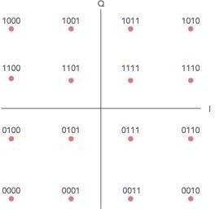
Figure 31: Bit sequence mapping for a 16QAM signal
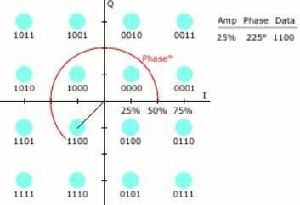
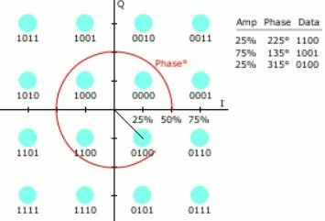
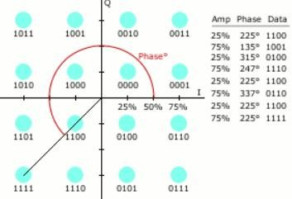
Conclusion
Figure 32: Digital 16-QAM with example constellation points
There is a wide array of techniques in which communication signals are modulated to simplify their transmission. Each of the techniques have been seen to have advantages and limitations through the experimental demonstration of how they function. It is imperative to consider the various signal characteristics such as amplitude, frequency, speed of transmission, and phase components as well as the available devices when making a choice about a modulation method. Besides, the effect of interference and ease of use are other factors that could be considered in the signal modulation. Through the experimental demonstrations of the various modulation techniques, the functionality of each of them has been determined.

References
Electronics Notes. (2020). What is QAM: quadrature amplitude modulation. Retrieved from https://www.electronics-notes.com/articles/radio/modulation/quadrature-amplitude-modulation-what-is-qam-basics.php
Electronic Notes. (n.d.). What is Frequency Modulation, FM. Retrieved from https://www.electronics-notes.com/articles/radio/modulation/frequency-modulation-fm.php?
Fas.org. (n.d.). Amplitude Modulation. Retrieved from https://fas.org/man/dod-101/navy/docs/es310/AM.htm
Northern Illinois University. (n.d.). Binary Frequency Shift Keying. Retrieved from https://www.niu.edu/remote-lab/resources/graphical-user-interfaces/frequency-shift.shtml
Open Learn. (n.d.). 1.6 Phase-shift keying (PSK). Retrieved from https://www.open.edu/openlearn/science-maths-technology/exploring-communications-technology/content-section-1.6
Open Stax. (n.d.). Laboratory Generation of AM and DSB-SC. Retrieved from https://cnx.org/contents/gYKpOb5o@1/LABORAORTY-GENERATION-OF-AM-AND-DSB-SC

